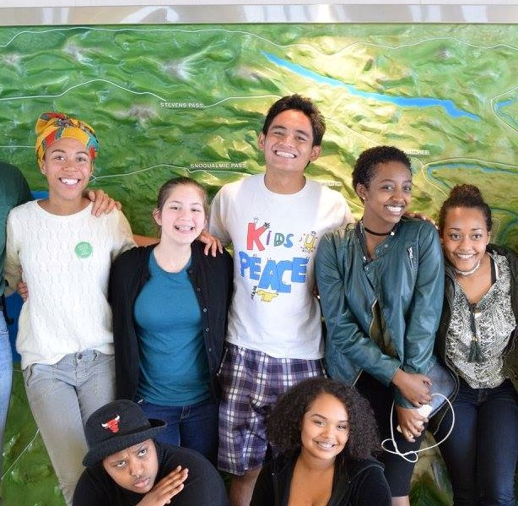
5
2
3
8
8
8
4
1
Azeb Tuji: 19 yr. old attending Shoreline Community College. Sea Tac, WA.
Project: Radio Journalism Production on Black Wxmen in Media; and a Photo series of Black Wxmen doing a variety of things to demonstrate the diversity of what being a black wxman entails, to be displayed at the Alice Gallery sometime in May of 2017.
1
[Grab your reader’s attention with a great quote from the document or use this space to emphasize a key point. To place this text box anywhere on the page, just drag it.]
[Cite your source here.]

SASHA LEE: 20 yr. old attending University of Washington. Seattle, WA.
Project: Organizing an intergenerational strategy/support group, using modern social media app.s, for community organizers to share resources that contribute to “impactful activism”.
2
EVE CHINEA: 14 yr. old attending Newport H.S. Bellevue, WA.
Project: Developing and teaching about “consent” and “rape culture” to 6th and 7th grade classes at Tyee Middle School. Eve had developed the curriculum with staff and worked with over 180 students, sharing videos and discussing the meaning and importance of “consent” over your body and your possession in young people’s lives.
EDWIN CARLOS: 19 yr. old attending Stanford University. From Renton, WA.
Project: Developing and promoting Nonviolent Communication, Emotional Intelligence and Self-Care strategies, including workshops and presentations; for the community of activists and peers at Stanford, beginning with the Pilipino-American community and then branching out.
ARIANA SUTHERLAND: 15 yr. old attending Holy Names Academy. Seattle, WA.
Project: Creating a visual media presentation aimed at elementary and middle-school students, from art produced by kids on what they think “beauty” is, to challenge implicit biases of “beautyism”, an aspect of sexism and racism, which erodes the self-esteem of young people dissimilar from a Eurocentric beauty norm.
MELEN GHEBRAI: 17 yr. old attending Shorewood High School. Shoreline, WA.
Project: Establish a Students of Color Union at Einstein Middle School to create a support system for students of color and raise awareness re issues prominent in communities of color that directly affect academic learning.
ELROHI (“ELLIE”) SHUGES: 17 yr. old attending Shorewood High School. Shoreline, WA.
Project: Establish a Students of Color Union at Einstein Middle School to create a support system for students of color and raise awareness re issues prominent in communities of color that directly affect academic learning.
MERON MADEBO: 21 yr. old attending Bellevue Community College. Renton, WA.
Project: Workshops and consciousness-raising on “colorism”, an aspect of racism, which discriminates based on the darkness/lightness of skin tone.

8
Not Pictured.
7
6
5
4
3

